Architecture Proposal for Scaling Fastier: Resilience, Performance, and Zero-Downtime
We are glad to hear about your recent growth of Fastier. It’s an exciting milestone, but it is understood having worries about possible server crashes and deployment downtime during such critical periods.Fastier needs to sustain its current trajectory
Based on your current setup, a single t3.medium running your entire stack, it’s clear you’ve outgrown your current "all-in-one" footprint. To address the issue of having memory bottlenecks, moving from a single t3.medium instance to a distributed and managed cloud architecture is one of the solutions. With regards to this, our team designed a scalable architecture revolving around AWS Elastic Beanstalk. With this, your team can now focus on Python/Flask development rather than infrastructure management by prioritizing speed to market and reduced operational overhead.
The Architecture Strategy
The services we will use are listed below:
- Route 53
- Elastic Load Balancing
- Elastic Beanstalk with Autoscaling EC2 Group
- RDS
- S3
- CodePipeline
- Amazon Cloudfront (CDN)
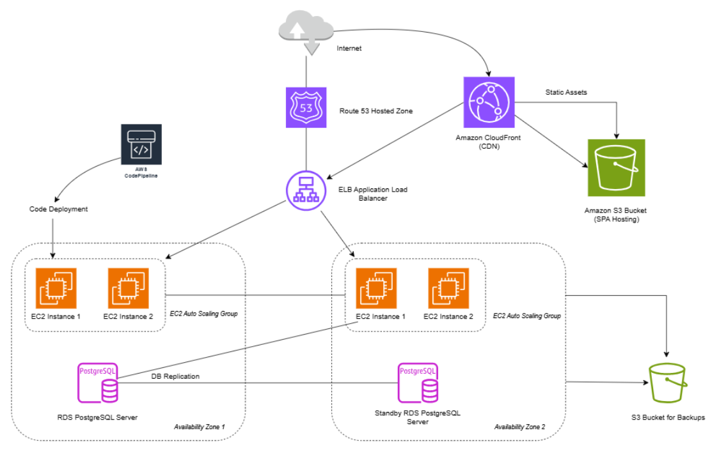
The mentioned components are included to the architectural design to resolve your three primary pain points:
- Performance
- Reliability
- Deployment Downtime
1. Solving Performance and Memory Issues
Currently, your Python app and PostgreSQL database are competing for the same 4GB of RAM. We will decouple them:
- Amazon RDS (PostgreSQL): To remove the database load from your application server and provide automated backups and scaling, we’ll migrate your data to a dedicated RDS instance.
- Auto Scaling Groups (ASG): Instead of one fixed server, Elastic Beanstalk will automatically add or remove EC2 instances based on real-time traffic. If you have a surge in users, the infrastructure expands; when traffic drops, it shrinks to save costs.
2. Ensuring High Availability (Disaster Recovery)
To address your company’s problem of having a lack of a disaster recovery plan, we recommend a Multi-Availability Zone deployment:
- Redundancy: It is highly recommended that the application will run across two separate data centers (AZs). The Elastic Load Balancer (ELB) will automatically shift all traffic to the healthy one in case one center experiences an outage.
- Database Failover: To ensure that data remains available even during a server failure, a Standby RDS Instance can be enabled in a second availability zone that stays in sync with the primary
3. Achieving Zero-Downtime Deployments
To eliminate the downtime you're seeing during updates, we will implement AWS CodePipeline and Blue/Green Deployments:
- The Process: When a new version of the app is deployed to a separate temporary environment (Blue), and verified if it’s working perfectly, Route 53 shifts traffic from the old version (Green) to the new one.
- The Benefit: Users never see a "503 Service Unavailable" page, and if there is a bug in the new code, we can roll back to the old version instantly without impacting live users
4. Modernizing the SPA Delivery

Since your front-end is a React SPA, we have a high-impact optimization:

Instead of serving React from your Flask server, we can host the static files on Amazon S3 and deliver them via Amazon CloudFront (our Content Delivery Network).

This ensures your global users experience lightning-fast load times by serving files from "edge locations" closer to them, while further reducing the memory load on your Flask API.

5. Cost Efficiency and Management
We are mindful that while your growth is high, your budget is not unlimited.
- Elastic Beanstalk is a free service—you only pay for the underlying resources (EC2, RDS, etc.) it manages.
- S3 provides highly cost-effective storage for your backups.
- Pay-as-you-grow: With Auto Scaling, you only pay for extra compute capacity when you actually have the traffic to justify it.
I recommend we jump on a quick call to walk through this diagram together. Once we’ve confirmed your current traffic metrics, I can use the AWS Pricing Calculator to provide a concrete monthly estimate that fits your growth trajectory.
Just let us know if you would like me to set up a brief 15-minute walkthrough of this proposed architecture.
Once again, thank you and congratulations.
Best regards,
Juanito M. Ramos II
AWS Solutions Architect

